What is SEO?

Search engine optimization is the process of maximising the number of visitors to a particular website by ensuring that a site appears high on the search list results.

What is SEM?

Search engine marketing is form of internet marketing that increases the promotion of websites by increasing their visibility in search engine page results.

Search engine statistics:

Google accounts for 91.84% of all search engine searches (2017).

Google has over 2 trillion searches per year (2016).

Yahoo had annual revenue in 2016 of 5169 million U.S dollars

Bing has an average of 873,964,000 searches per day.

Examples of SEO and SEM.

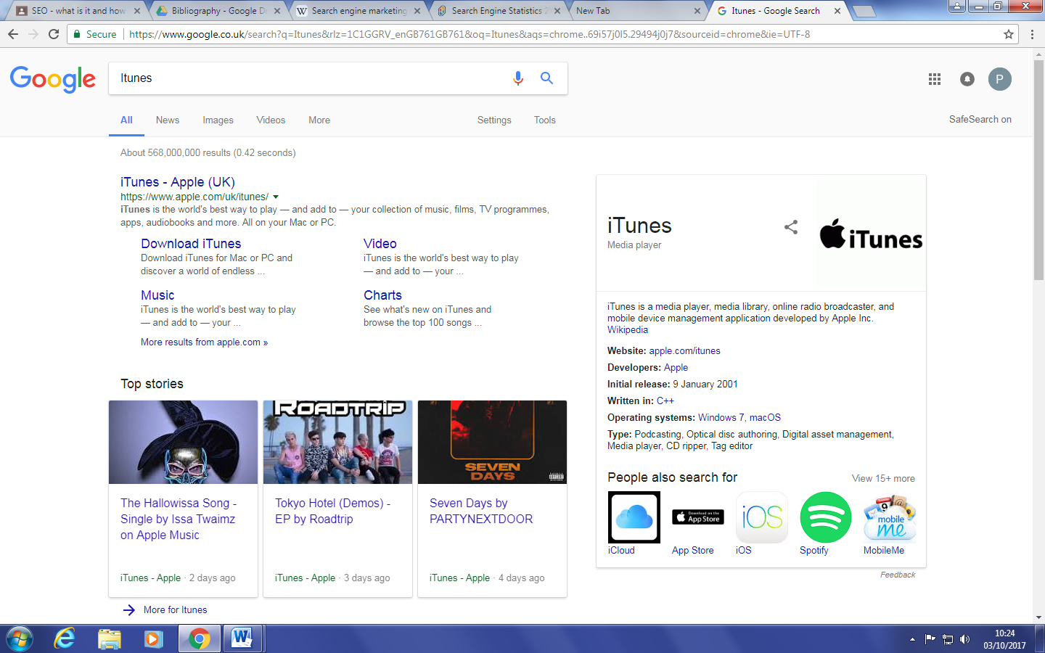

The image above is an example of search engine optimization as the key word I entered in the search engine ‘ITunes’ is the first result on google.

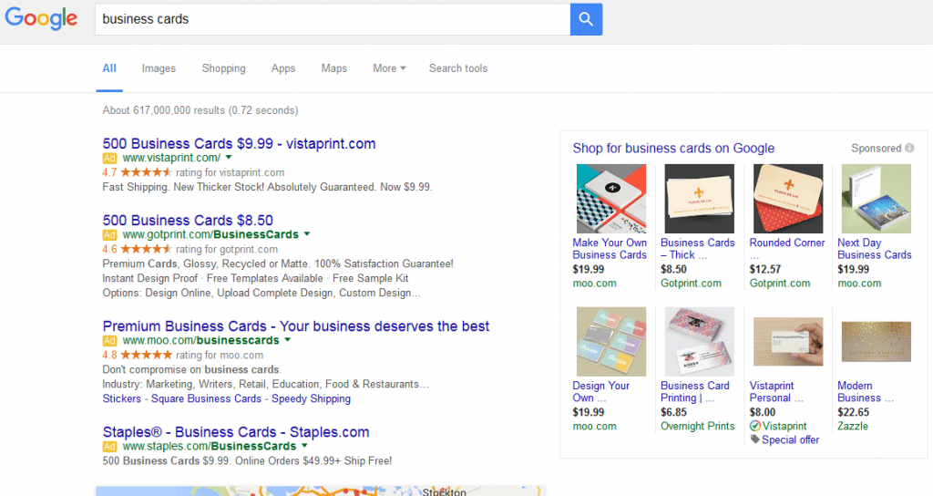

The image above is an example of SEM as when business cards are entered into the search engine. There are multiple ads that give examples of shopping websites that sell business cards.